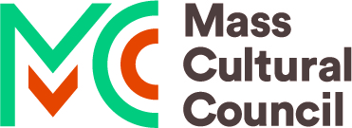

A workshop will be held in the Alford Town Hall on Sunday November 27, 2022. The session will begin at 1:00pm and end at 3:00 pm with a staggered class structure-participants may drop in any time with a cut off time of 2:30pm. There will be a $10 materials fee payable by cash or Venmo. Participants will learn how to create a mixed green wreath using local greens and materials to create a beautiful 12” wreath to celebrate the Winter season and the return of longer days. Please sign-up @ prahenden@gmail.com or
413-854-8554 or to inquire about the class.

This program is supported in part by the Alford/Egremont Cultural Council which is a local agency funded by the Mass Cultural Council, a state agency.

